**Install and configure NFS server**

Install NFS server component package on server X and NFS client component on client machine Y

Network File Sharing (NFS) is a protocol that allows you to share directories and files with other Linux clients over a network. Shared directories are typically created on a file server, running the NFS server component. Users add files to them, which are then shared with other users who have access to the folder.

Install NFS server component package on server X 172-31-39-210

Yum install nfs-utils

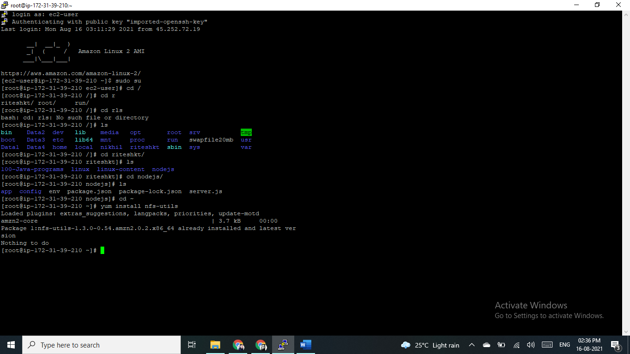

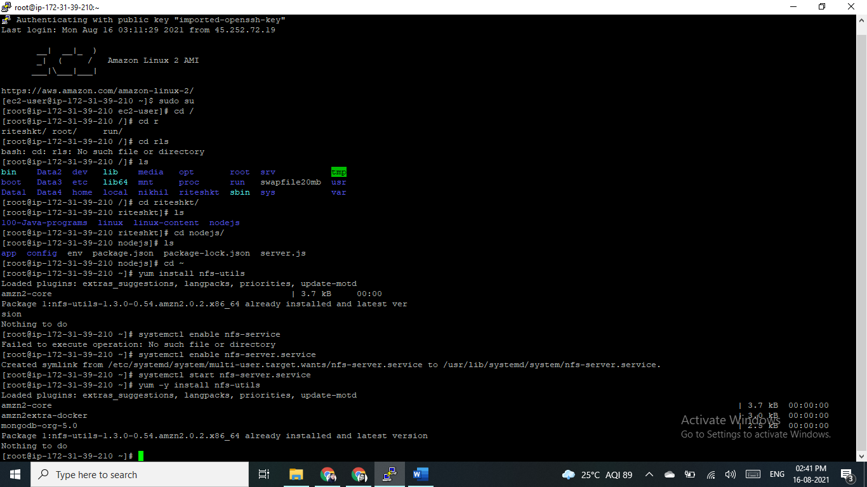

**Create Root NFS Directory**

We’ll now create the root directory of the NFS shares, this is also known as an export folder.

sudo mkdir /mnt/myshareddir

Set permissions so that any user on the client machine can access the folder (in the real world you need to consider if the folder needs more restrictive settings).

sudo chmod 777 /mnt/myshareddir #everyone can modify files

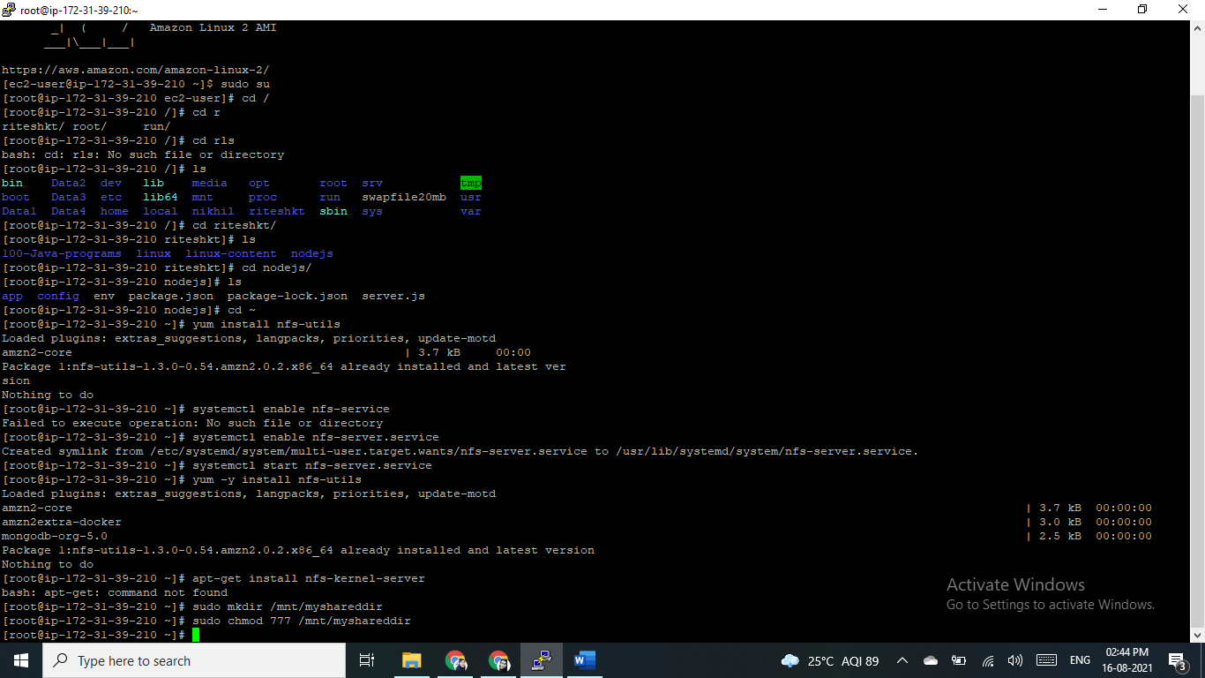

Define Access for NFS Clients in Export File

To grant access to NFS clients, we’ll need to define an export file. The file is typically located at /etc/exports

Edit the /etc/exports file in a text editor, and add one of the following three directives.

All the directives below use the options rw, which enables both read and write, sync, which writes changes to disk before allowing users to access the modified file, and no_subtree_check, which means NFS doesn’t check if each subdirectory is accessible to the user.

**To enable access to a single client**

/mnt/myshareddir {clientIP}(rw,sync,no_subtree_check)

**To enable access to several clients**

/mnt/myshareddir {clientIP-1}(rw,sync,no_subtree_check)

{clientIP-2}(...)

{clientIP-3}(...)

**To enable access to an entire subnet**

/mnt/myshareddir {subnetIP}/{subnetMask}(rw,sync,no_subtree_check)

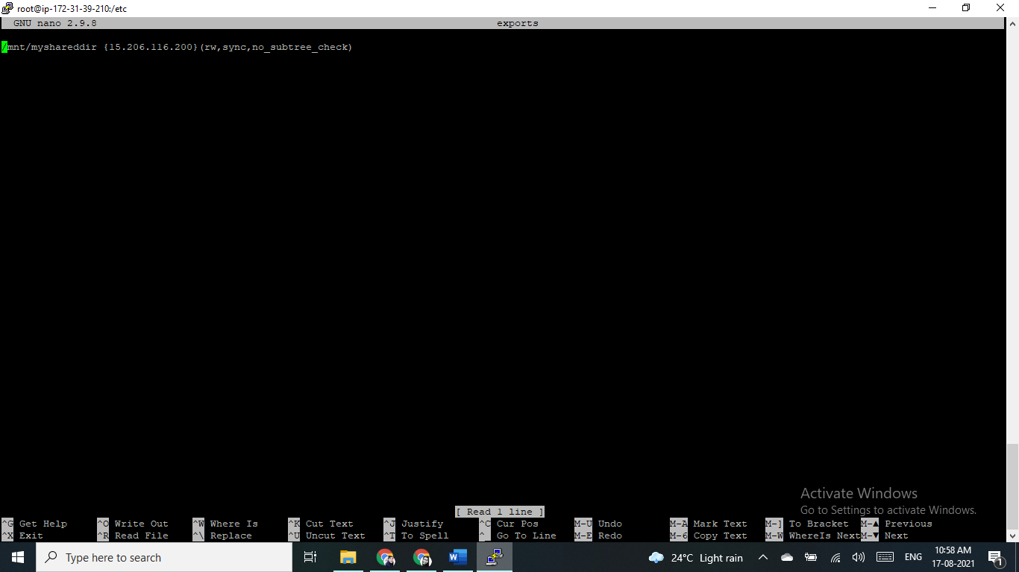

Make the NFS Share Available to Clients

You can now make the shared directory available to clients using the exportfs command. After running this command, the NFS Kernel should be restarted.

sudo exportfs -a #making the file share available

sudo systemctl restart nfs-kernel-server #restarting the NFS kernel

Setting Up NFS on Client Machine and Mounting an NFS Share

Now that we have set up the NFS server, let’s see how to share a folder, defined as an NFS share, with a Linux computer by mounting it on the local machine.

Installing NFS Client Packages

sudo yum install nfs-utils

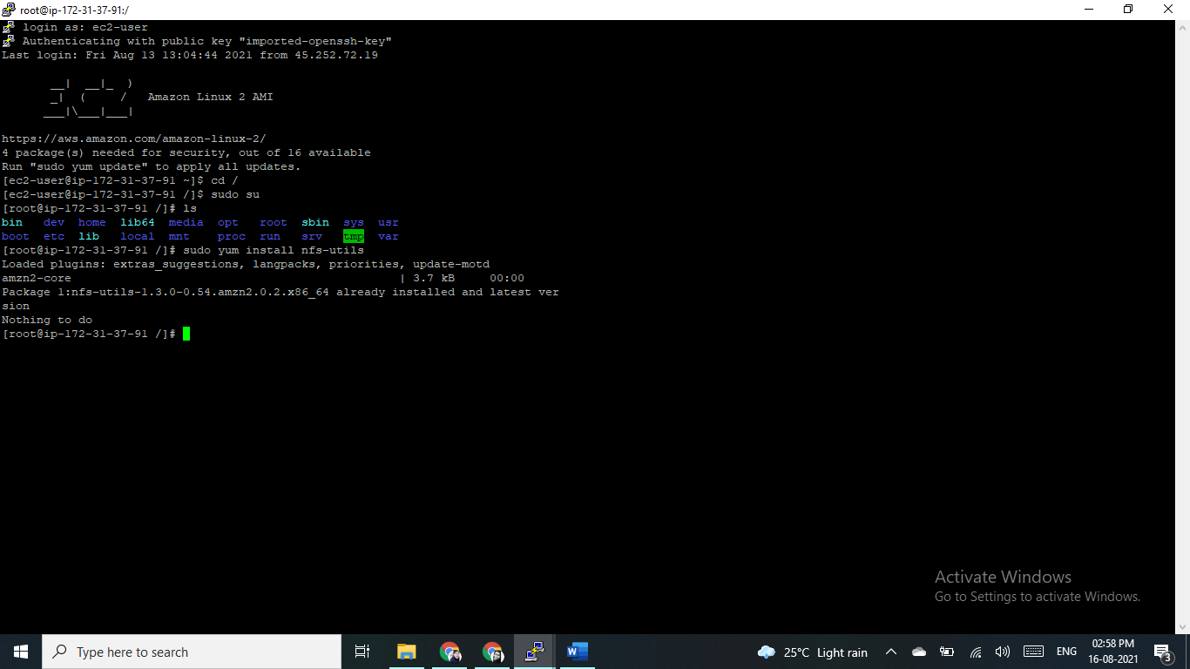

Mounting the NFS File Share Temporarily

We can mount the NFS folder to a specific location on the local machine, known as a mount point, using the following commands.

Create a local directory—this will be the mount point for the NFS share.

Example we’ll call the folder /var/locally-mounted.

sudo mkdir /var/locally-mounted

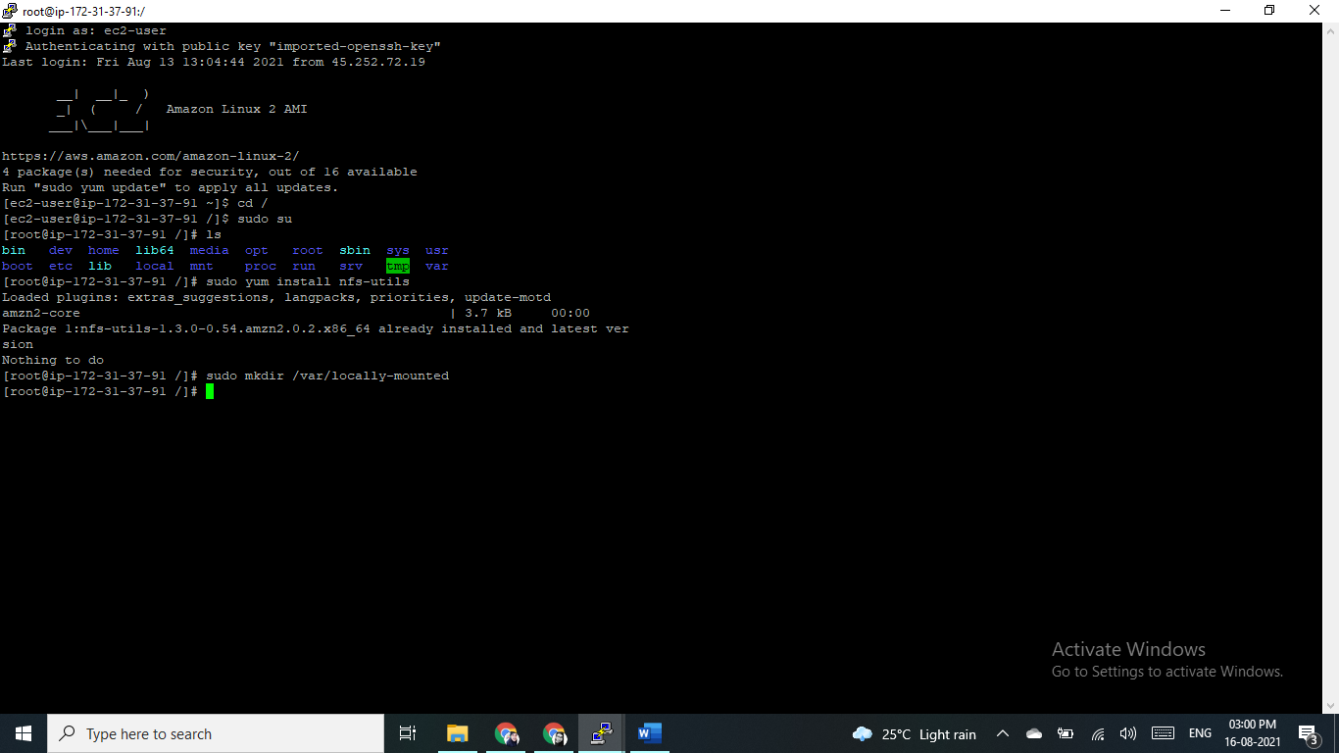

Mount the file share by running the mount command, as follows. There is no output if the command is successful.

# sudo mount -t nfs 172.31.39.210:/mnt/myshareddir /var/locally-mounted

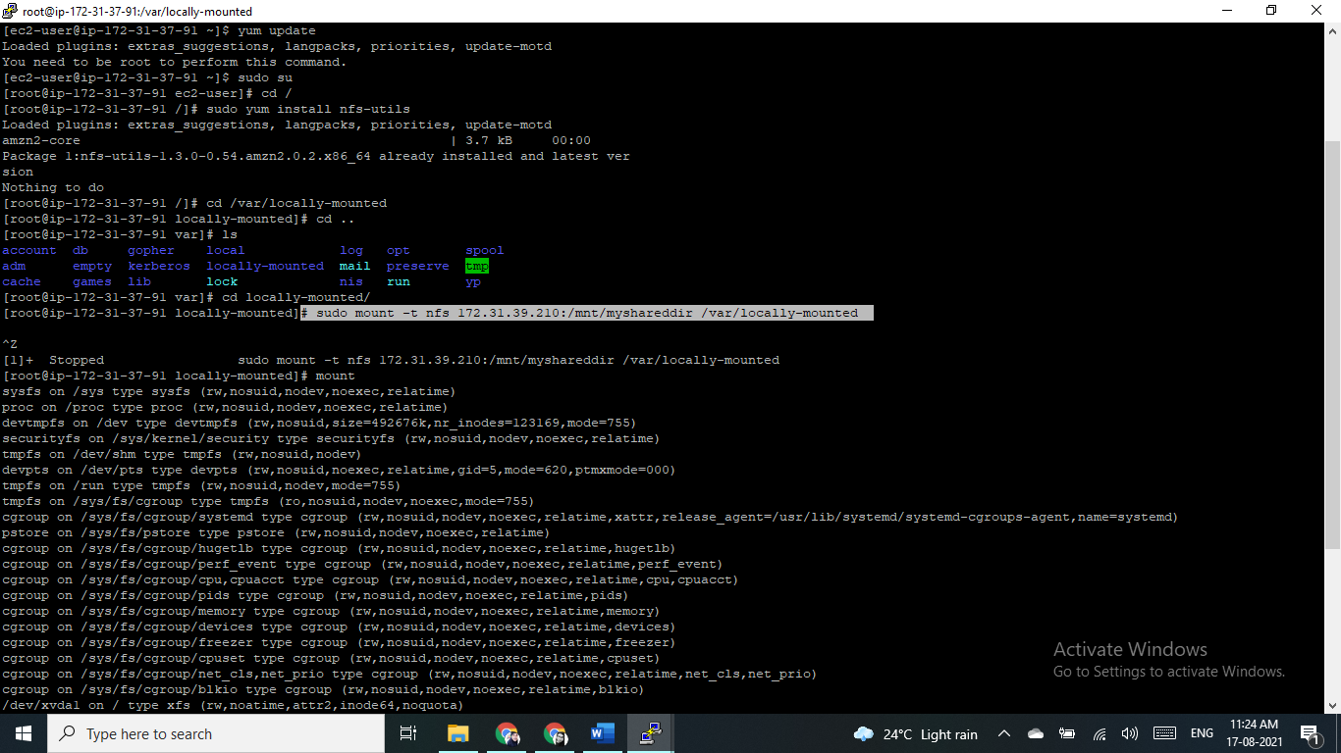

The mount point now becomes the root of the mounted file share, and under it you should find all the subdirectories stored in the NFS file share on the server.

To verify that the NFS share is mounted successfully, run the mount command or df -h.

### Mounting NFS File Shares Permanently

Remote NFS directories can be automatically mounted when the local system is started. You can define this in the /etc/fstab file. In order to ensure an NFS file share is mounted locally on startup, you need to add a line to this file with the relevant file share details.

To automatically mount NFS shares on Linux, do the following:

Create a local directory that will be used to mount the file share.

sudo mkdir /var/locally-mounted

Edit the /etc/fstab file using the nano command or any text editor.

Nano /etc/fstab

{172.31.39.210}:{/mnt/myshareddir} /var/locally-mounted nfs defaults 0 0

